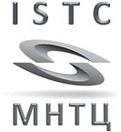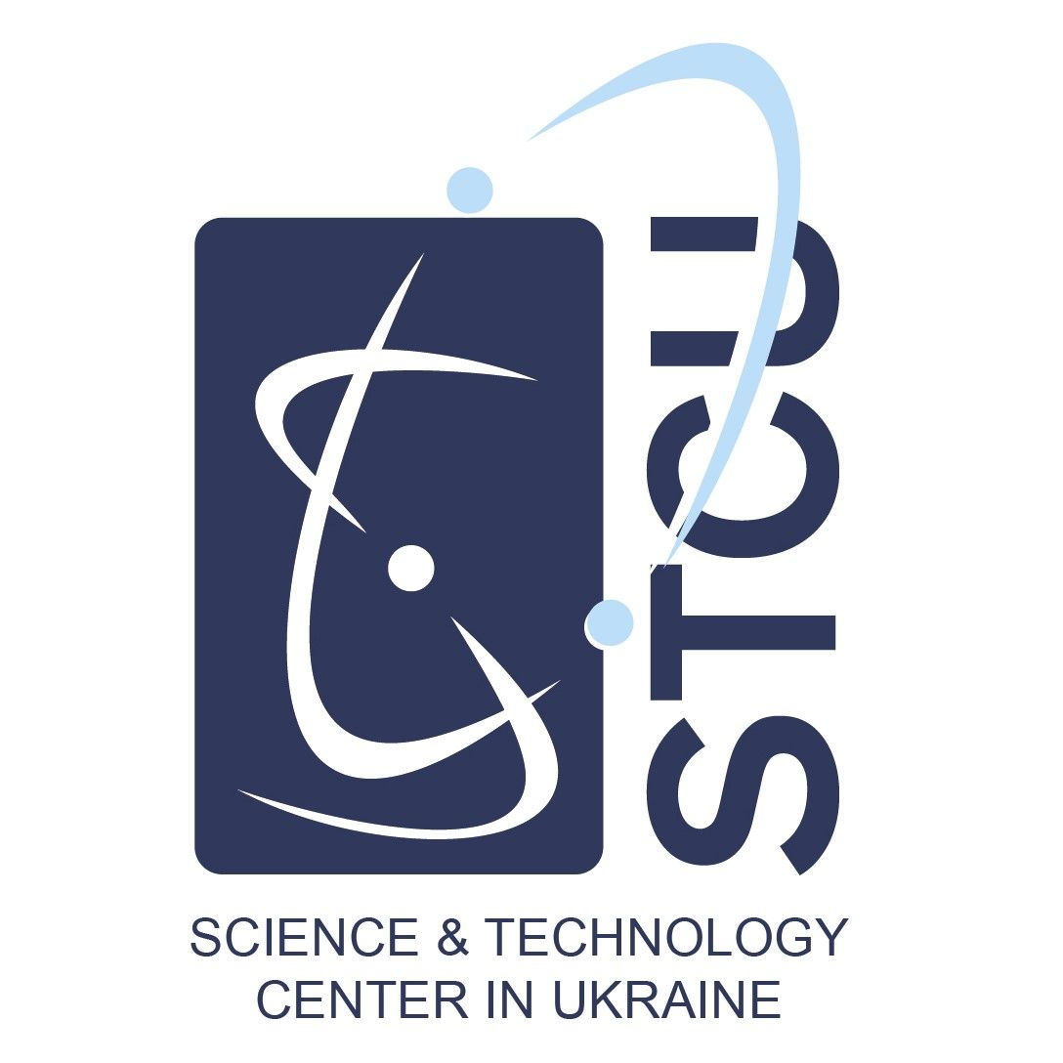
Nuclear forensics fellowship 2022 - 2024
Call for applications for full-time master’s degree
in the framework of
International Science and technolgy Center/Science and technolgy Center in ukraine
Nuclear forensics Targeted IniTiative
supported by the
US Department of Energy/National Nuclear Security Administration

This competitive fellowship provides two years of funding to attend a master’s degree program in an area relevant to nuclear forensics (i.e., physics, chemistry, engineering, etc.). Selected fellows will also receive mentoring from a laboratory or university mentor in the area of nuclear forensics, a virtual mentor from a United States National Laboratory, and funding to attend two conferences per year to present research findings and broaden professional network. Upon completion of the fellowship, students contractually agree to work in the field of Nuclear Forensics for a period of two years in their country of citizenship.

Name applicant
Indicative research project title  This text will be used for administrative purposes only. This text will be used for communication purposes on internal and external websites. We suggest not to include any confidential information. | ☐ Nuclear Physics (Forensics concentration)  ☐ Nuclear Chemistry (Forensics concentration)  ☐ Nuclear Engineering  ☐ Other: _______________________________________________
Annexes: | ☐ Copy of the candidate’s diploma and study results*  ☐ Copy of the CV must be included *  ☐ Copy of the letter of support from Master’s supervisor from Moldova must be included *  ☐ Motivational letter*
Signature of applicant | (date)
Signature of supervisor in one of the following countries: Moldova | (date)
*Required annex: without this annex, the application will be declared inadmissible

This application document shall be filled out in English.

Deadline: 15 January 2022

Mail to elena.taberko@stcu.int for applications from Moldova

Note: Only upon reception of a confirmation email has your application been successfully submitted.
Part I - Personal Information

1. Personal data

First Name
Last Name
Other Names
Gender
Date of birth
Place of birth
Country of birth
Nationality

Civil status

Home address: street and number
postal code and city
country
telephone

Mailing address: street and number
postal code and city
telephone

Email

2. Educational background

Year of graduation secondary education:
Higher Education* | Name of program | Institute of Higher Education/  University | Score / degree | Date completed
1st Bachelor
2nd Bachelor
1st Master
2nd Master

*Copy of the diploma and study results per year must be included

Please indicate in the table below your rank within your graduating class for all Bachelor and Master degrees (please contact your university for this information)

 | Name of program | Rank
Bachelor
Master

3. Bachelor’s Thesis

Supervisor
Title
Year
University / institute of higher education
Brief thesis description

4. Professional background (if applicable)

Employer | Hours/week | Position | Period

5. If you have pursued scientific/scholarly studies and/or have experience abroad (other than mentioned in attached diplomas), please list them here.

6. If you have already received any grants not previously mentioned since the completion of your studies, please list them here (including any current positions, stating whether these positions are renewable and whether you have applied for renewal).

7. If you have already published scholarly/scientific articles, please list them with complete bibliographical information.

8. Other elements of added value that are complementary to your CV can be listed here.

By signing here, I attest that all information I’ve provided is correct to the best of my knowledge. Additionally, I agree that if selected, I will work in my country of citizenship for a period of two years in the field of nuclear forensics.

Name of Applicant________________________________________________

Signature ______________________ Date_______________

